**SN Development**

# The project structure

Synchronization component for FRMS is located in frms-platform GIT repository. To checkout from Arbonaut GIT server:

http://vserver3:9009/scm/git/frms-platform

build datamodel frms-context

frms-report-app frms-syncclient frms-test scripts

Components are managed as Maven modules.

# FRMS SymmetricDS

SymmetricDS component for FRMS is located in frms-symmetricds GIT repository. To checkout from Arbonaut GIT server:

http://vserver3:9009/scm/git/frms-symmetricds

symmetric-android symmetric-assemble symmetric-client symmetric-client-clib

symmetric-client-clib-assemble symmetric-client-clib-test symmetric-client-native symmetric-core

symmetric-csv symmetric-db symmetric-io symmetric-jdbc symmetric-parent symmetric-server symmetric-util symmetric-wrapper

## Build SymmetricDS

To build SymmetricDS and install artifacts to local Maven repository, run the following commands:

cd symmetric-assemble

./gradlew build publishToMaven

To setup Eclipse development environment run the following commands:

cd symmetric-assemble

./gradlew develop

# Prepare Eclipse IDE development Environment

## Configure and build projects

Load the following projects into Eclipse from frms-platform repository:

**/frms-platform** (parent Maven project)

**/frms-platform/frms-syncclient** (main FRMS Synchronization project)

**FRMS SymmetricDS** projects can be added into Eclipse. Update Maven projects.

Execute Maven goals to prepare development of RA in Eclipse IDE:

frms-platform> mvn --projects frms-context,frms-test --also-make clean install

Now build **frms-syncclient**

## Launch configuration

Create launch configuration as follows:

### Main

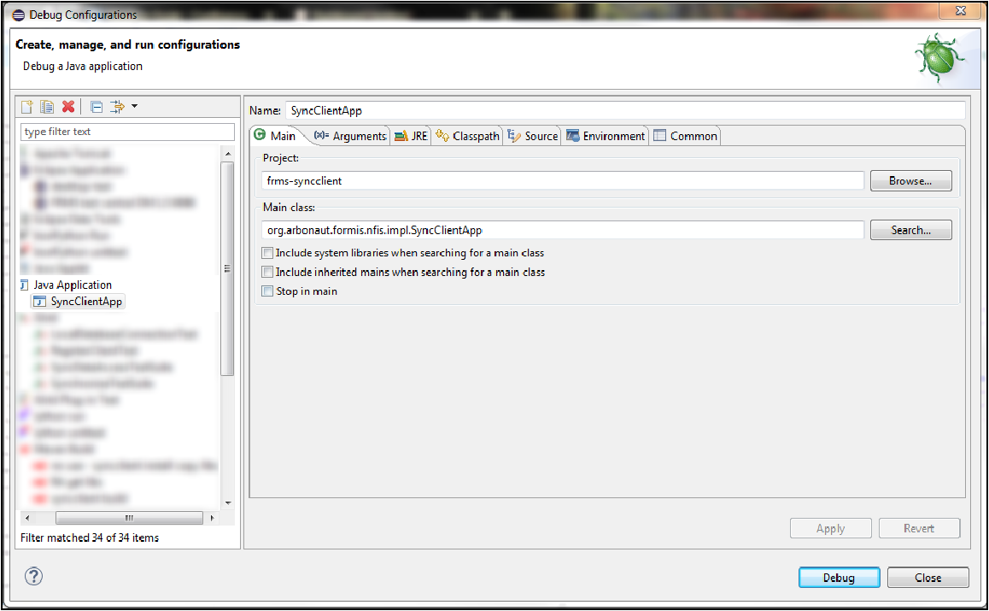

**Arguments**

Set argument **-Dsync.properties_file** to point to existing Synchronization configuration file

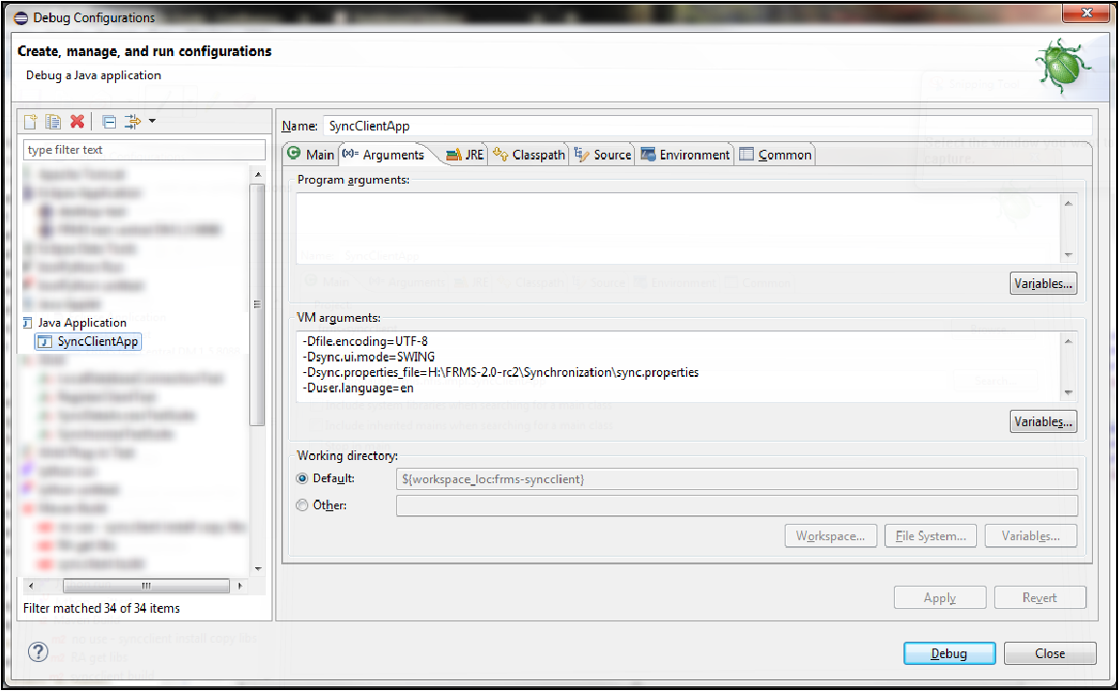

Run project. Of course, local database must be running :)

# Build by Maven

In order to build the FRMS Synchronization component run following Maven commands within a working copy of **frms-platform** repository

frms-platform> mvn --projects frms-context,frms-test --also-make clean install frms-platform> mvn clean install

FRMS Synchronization artifact is created in /frms-platform/frms-syncclient/target.

To collect required libraries, run command frms-platform> mvn package

Libraries are copied to /frms-platform/frms-syncclient/target/lib.

If profile frms-component-deploy is given to package command, zip packages are created from libraries, startup script and configuration files and deployed to **\\dell-testi\Powerline2\FRMS Vietnam\FRMS-2.0\ClientPackage-Components\SN**. It is usually best ti leave this to CI server.

# CI at Jenkins

FRMS SymmetricDS component is configure at Jenkins CI server to be built and installed into local Maven repository.

http://vserver3:8090/jenkins/job/FRMS-SymmetricDS/

FRMS SymmetricDS component is configure to be built weekly. FRMS Synchronization build will follow.

FRMS Synchronization component is configured at Jenkins CI server to be built and deployed to **\\dell-testi\Powerline2\FRMS Vietnam\FRMS-2.0\ClientPackage-Components\SN**

http://vserver3:8090/jenkins/job/FRMS-SN/

Nighly building process is configured. Separate packages are created configured for Vietnam test server and Arbonaut internal test server.